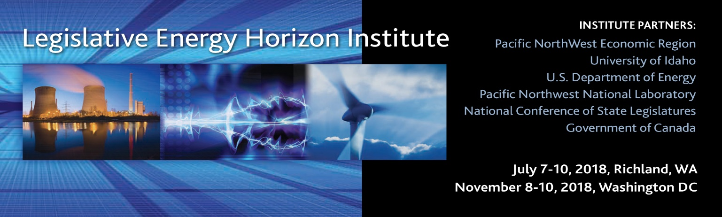
2018 Richland Class Agenda ©
Friday July 6, 2018 -Travel Issues? Text or call Jeff @ 360.941.5678
2:00-5:30pm | If you signed up for optional tour of the 1GW Columbia Nuclear Generating Station Bus leaves hotel at 1:30pm
6:30-8:30pm | Hospitality Welcome for Participants arriving July 7, 2018  Point Room @ Courtyard by Marriott, Richland Columbia Point  480 Columbia Point Drive | Richland, WA 99352 | (509) 942-9400
8:30-11:00pm | Hospitality Suite Open—Room 215 at Hotel
Saturday July 7, 2018
All Classroom Sessions Discovery Hall-650 Horn Rapids Road, Richland, WA 99354
6:00-8:15am | Breakfast at Hotel, order breakfast at your leisure (Please bring government ID with you to get your security badge.)
8:15am | Bus Departs for Pacific Northwest National Laboratory  Badging office is across from the Discovery Hall entrance to your right
9:15am | Welcome—Official Course Start Pre-Course Self-Knowledge Assessment  Jeff Morris/Yvonne Sertich
9:30-10:25 | Aligning Regulation with State Energy Policy  Roger Woodworth, Principal, Mindset Matters
10:30-12:15pm | Electric Power Generation, Transmission, and Distribution  University of Idaho Faculty Skip Collier (Breaks called by Instructor)
12:15-1:00pm Lunch | Class Introductions and Discussion of Morning Sessions EMSL 1077
1:05-5:00pm | Electric Power Generation, Transmission, and Distribution  University of Idaho Faculty Skip Collier (Breaks called by Instructor)
5:05-7:00pm  Bus to Dinner | CASUAL DINNER  Roundtable discussion of the day and top-of-mind energy issues  Ste. Michelle Wine Estates WSU Wine Science Center
7:00pm | Bus Departs for Hotel
8:00-10:00pm | Hospitality Suite Open—Room 215 at Hotel
Sunday July 8, 2018
All Classroom Sessions Discovery Hall-650 Horn Rapids Road, Richland, WA 99354
7:45am | Bus Departs for PNNL
8:00-8:30am | Breakfast at PNNL Discovery Hall
8:30-9:25am | Rate of Return 101  Dave Danner, Chair, Washington State Utilities and Transportation Commission
9:30-11:00 am | Natural Gas 101 Production, Transmission, and Delivery  University of Idaho Faculty Dick Moore (Breaks called by Instructor)
11:05-12:30pm | Petroleum 101  University of Idaho Faculty Dick Moore
12:30-1:45pm  Lunch onsite | PNNL’s Energy Infrastructure Operations Center  Presentation by Dr. Jud Virden, Associate Laboratory Director for Energy and Environment, PNNL, Systems Engineering Building (Class split into two groups to tour center and have lunch via food truck!)
1:55-2:55pm | Electric Vehicles, the Grid, and Human Behavior  Don MacKenzie, Professor of Civil and Environmental Engineering, University of Washington
3:00-3:55pm | Natural Gas Vehicles, What Infrastructure is Needed?  Derek D. Turbide, Vice President, Clean Energy
4:00-4:45pm Board Bus and transport to Williams LNG  4:50-6:00pm Tour  Dinner 6:00-6:55pm  7:00pm | Presentation in Route, Smart Communities  Williams LNG & Pipeline Compression Facility Tour  Williams Northwest Pipeline Company  42612 Christy Rd  Plymouth, WA 99346  Bus Departs for Hotel
8:00-10:30pm | Hospitality Suite Open—Room 215 at Hotel

Monday, July 9, 2018
All Classroom Sessions Discovery Hall-650 Horn Rapids Road, Richland, WA 99354
7:30am | Bus Departs for PNNL
7:45-8:15am | Breakfast at PNNL Discovery Hall
8:20-9:15am | How a Regulated Utility Finances Energy Projects  William L. “Bill” Murray, Vice President, State and Electric Public Policy, Dominion Energy
9:25-10:20am | Subscription and Financing Process for Wholesale Natural Gas Pipelines  Jay White, Vice President, US Pipelines Marketing, TransCanada Pipeline LTD
10:25-11:20am | Canada’s Energy Situation  Dale Eisler, Senior Policy Fellow, Johnson Shoyama Graduate School of Public Policy, University of Regina
11:20am-12:15pm | Public Power 101  Tanya DeRivi, Director of Government Affairs, Southern California Public Power Authority
Lunch 12:15-12:50pm | Class Debrief and Discussion
1:00-2:45pm | Integrated Resource Planning Exercise, EMSL 1077/75  Jason Thackston, Senior Vice President of Energy Resources, Avista Corp.
2:50-3:50pm | Canadian Natural Gas and Developing New Markets  Donny van Dyk, Government Affairs Strategist, Enbridge
4:00-4:50pm | Integrating Renewables  Ben Sigrin, Researcher IV-Model Engineering, The National Renewable Energy Laboratory
5:00pm | Bus Departs for Dinner
5:30-7:30pm  Social and Dinner  Dinner Sponsored  by Dominion Energy | Energy—The Next 20 Years  David Anderson, CEO, Northwest Natural Gas Company  The Reach Museum  "Our primary mission will be one of storyteller...Looking through the lens of the Hanford Reach National Monument and the Columbia River."  1943 Columbia Park Trail, Richland, WA 99352  (509) 943-4100
8:30-10:00pm | Hospitality Suite Open—Room 215 at Hotel

Tuesday, July 10, 2018
All Classroom Sessions Discovery Hall-650 Horn Rapids Road, Richland, WA 99354
7:15am | Bus Departs Hotel for PNNL (check in for your flight before you leave hotel)
7:45-8:15am | Breakfast at PNNL Discovery Hall
8:15-9:30am | Smart Grid 101  Carl Imhoff, Manager, Electricity Infrastructure Market Sector, Pacific Northwest National Laboratory
9:35-11:35am | What Will Utility Business Models and Regulation Look Like in 2030?  Andy Satchwell, Senior Scientific Engineering Associate in the Electricity Markets and Policy Group, Lawrence Berkeley National Laboratory
11:35am-12:00pm | Lunch  Preview of DC Class Session & Wrap Up
12:00pm | Bus Departs for Hotel then to Airport Direct

